

LOVELY PROFESSIONAL UNIVERSITY

A

Project work

On

“Photoshoot website”

For the Course

CSE- 326, HTML (Hypertext Markup Language)

**Project done by: -**

1. Amardeep Singh Gujraal (12006933)

2. Gauranga Kumar Bhuyan(12014189)

**Submitted to: -**

***Sukhvir Kaur.***

**Table of Content: -**

|  |  |
| --- | --- |
| Sr.No | Content |
| 1. | Acknowledgement |
| 2. | Introduction. |
| 3. | Development Tools. |
| 4. | Body. |
| 5. | Snapshots. |

Acknowledgement.

Presentation, Inspiration and motivation have always played a key role in the success of any venture.

We express our sincere thanks to our CSE teacher **Sukhvir Kaur** to encourage us to the highest peak. We immensely obliged to her for her elevating inspiration, encouragement, guidance and kind supervision in completion of our project.

This project us to do lot of research in our coding part and different skills to enhance and boost our every skill. Thank you, mam, for assigning with this project.

**Introduction.**

Hypertext Markup Language (HTML) is a simple markup system used to create hypertext documents that are portable from one platform to another. This platform helps all the user to design and create different websites using different language like Html, CSS, JavaScript etc.

The main objective of this project is to design a dynamic and responsive website on an online frame for the photographic purpose. This website helps in the management of photoshoot to capture all the memories one can want and it help people in future to cherries their past by seeing their highly good pictures. This website is a user friendly for all its user.

**Development Tools.**

1. Vs Code and Bootstrap

2. Language: CSS and Html.

3. Web Browser: Google Chrome, Microsoft edge.

**Body.**

What is Photoshoot?

A photo shoot is a term that describes the process taken by creatives and models that results in a predetermined visual objective being obtained. An example could be a model posing for a photographer at a studio or an outdoor location.[1]

A photo shoot is a series of images that are taken, with the goal of obtaining images that can then be placed into post-production, or editing. These images are then used for print/digital advertising, business collateral, or just for personal use.

An amateur photo shoot is more likely to be under the arrangement of Trade-For-Portfolio (TFP), whereas a professional photo shoot for a brand or product is likely to be a paid arrangement. With TFP photo shoots, the agreement is often that everyone involved in the shoot will receive the high-resolution, edited images as a form of payment.[2][3]

With professional photo shoots, the contract is generally signed via a representative modelling agency and so payment is generally always monetary. Due to this, models may not be guaranteed to get the images returned to them as it is the property of the hiring firm/individual. Many photo shoots hire models from professional modelling agencies, and may also hire stylists, makeup and hair artists

Login details

This photographic website can be accessed through the login details of the clients available on the website, they can login using their credentials like email id of the clients and employee id of staffs and finally by entering their password.

Details available on the Website home page.

Home page: - It contains all the features of website that help people to easily access the website.

About Us: - It contain all our details of so people can easily know about us and about our work too.

Wedding: - This section is specially for wedding photoshoots. It helps people to look our previous work on wedding function photoshoots that help them to make decision, whether they want to appoint us or not.

Family: - This section is specially for family photoshoots. It helps people to look our previous work on family photoshoots that help them to make decision, whether they want to appoint us or not.

Contact US: - This section contains all our contact details so people can reach us according to their comfort.

**Snapshots: -**

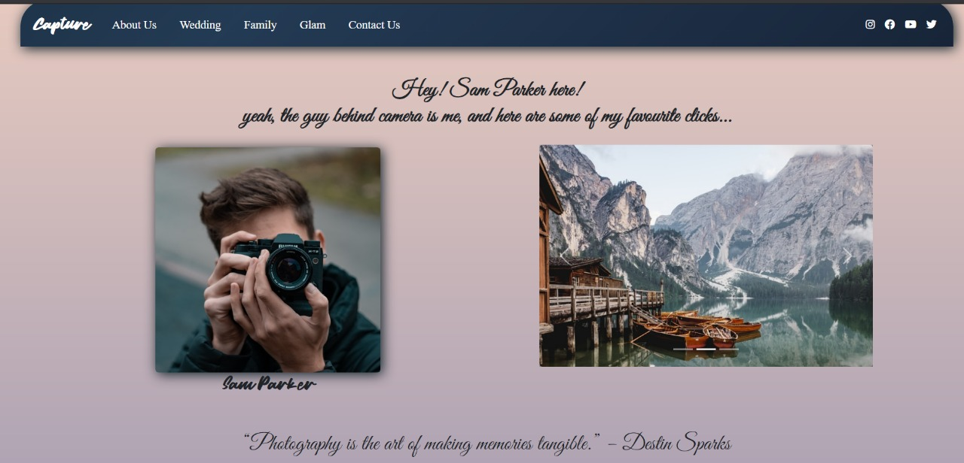

**Main Page**

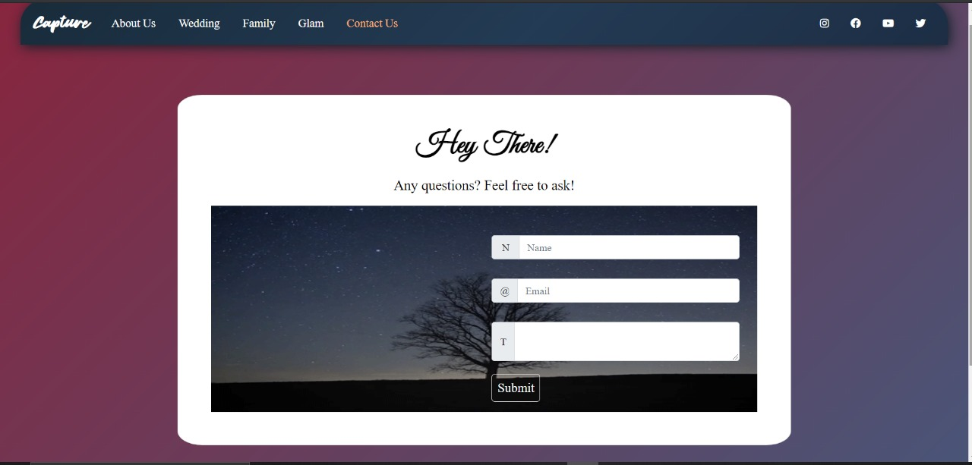

**Sign-in Page**

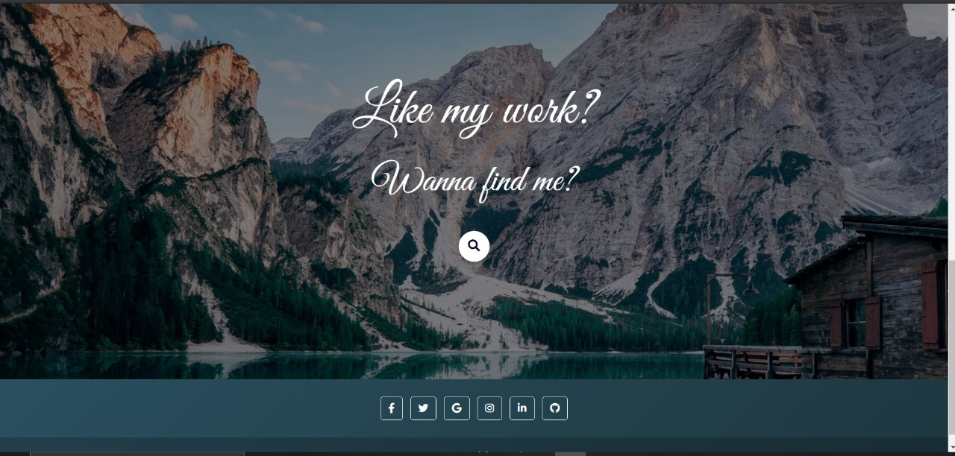

**Find Us Page**

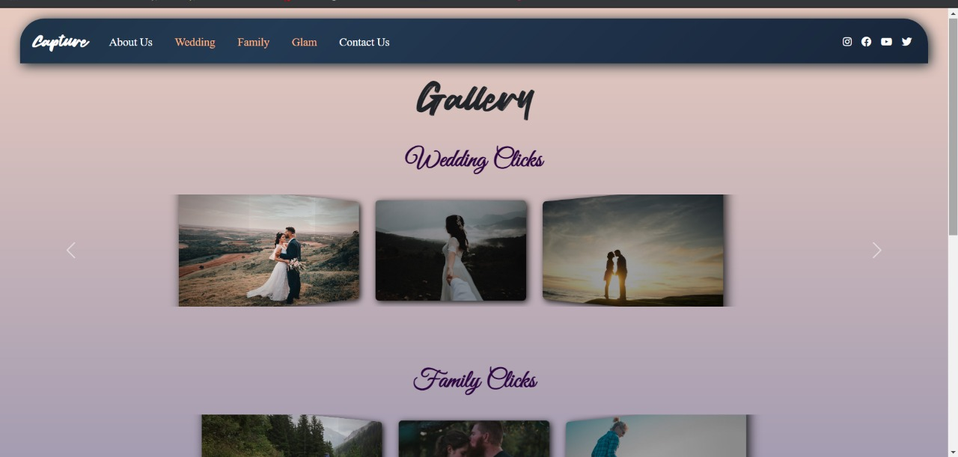

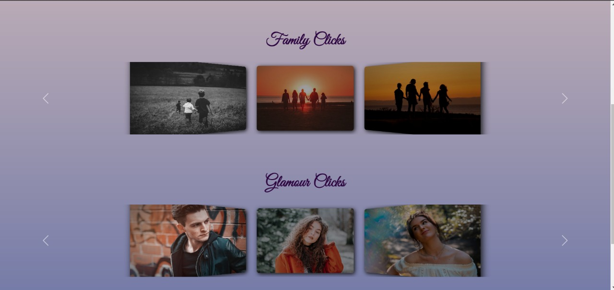

**Gallery Page**

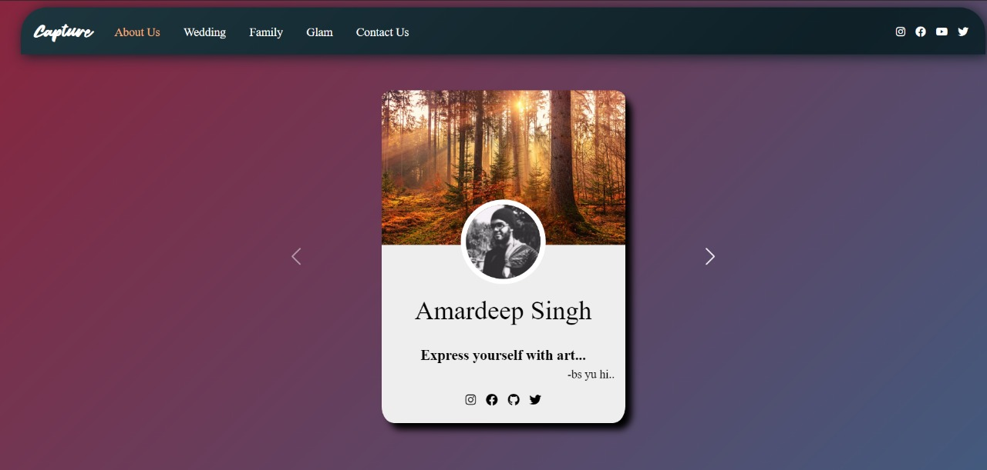

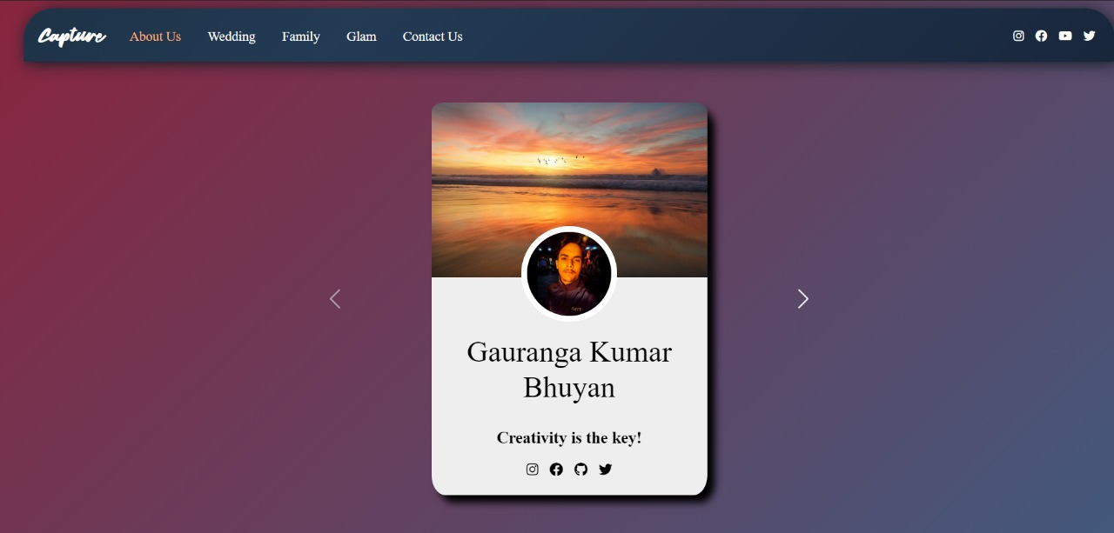

**Contact Us Page**

**THANKY YOU!**